PRACTICAL – 7
AIM:
Form Validation: Create custom @NotBlank and @MaxLength(int) annotations for form fields and apply them to a SignupForm. Develop a validation checker using reflection to examine these annotations and generate a list of validation errors for a given form object.

CODE:
import java.lang.annotation.*;
import java.lang.reflect.Field;
import java.util.ArrayList;
import java.util.List;

@Retention(RetentionPolicy.RUNTIME)
@Target(ElementType.FIELD)
@interface NotBlank {
}

@Retention(RetentionPolicy.RUNTIME)
@Target(ElementType.FIELD)
@interface MaxLength {
int value();
}

class SignupForm {

@NotBlank
String fullName;

@NotBlank
@MaxLength(10)
String userId;

@NotBlank
@MaxLength(20)
String passcode;

SignupForm(String fullName, String userId, String passcode) {
this.fullName = fullName;
this.userId = userId;
this.passcode = passcode;
}
}

class FormValidator {

public static List<String> checkForm(Object data) {

List<String> errorList = new ArrayList<>();

Field[] memberFields = data.getClass().getDeclaredFields();

for (Field member : memberFields) {

try {
member.setAccessible(true);

String fieldValue = (String) member.get(data);

if (member.isAnnotationPresent(NotBlank.class)) {
if (fieldValue == null || fieldValue.trim().isEmpty()) {
errorList.add(member.getName() + " cannot be blank");
}
}

if (member.isAnnotationPresent(MaxLength.class)) {

MaxLength limit = member.getAnnotation(MaxLength.class);

if (fieldValue != null && fieldValue.length() > limit.value()) {
errorList.add(member.getName() + " cannot be more than "
+ limit.value() + " characters");
}
}

} catch (Exception ex) {
System.out.println("Error while validating field");
}
}

return errorList;
}
}

public class Main {

public static void main(String[] args) {

SignupForm signup = new SignupForm(
"",
"verylongusername123",
"mypassword"
);

List<String> result = FormValidator.checkForm(signup);

if (result.isEmpty()) {
System.out.println("Form is valid");
} else {
System.out.println("Validation Errors:");

for (String message : result) {
System.out.println(message);
}
}
}
}

OUTPUT SCREENSHOT:
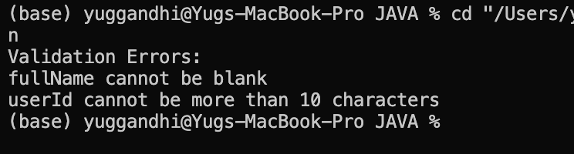
LEARNING OUTCOME:
  - Understand the use of try-catch-finally blocks for handling exceptions in Java.
  - Implement custom exceptions for handling specific calculator errors.
  - Learn to validate user input and handle invalid numbers, operators, negative values, and division by zero.
  - Use user-defined methods to improve code modularity and readability.
  - Develop a user-input-based calculator with repeated execution and proper exception handling.

PRAC-2
Mini Test Runner: Create a custom @Run annotation and apply it to some methods that do not take any arguments. Using reflection, identify and execute only the methods marked with @Run, then display the total number of methods executed. This demonstrates the basic concept used by JUnit to detect @Test methods.

CODE:
import java.lang.annotation.*;
import java.lang.reflect.Method;

@Retention(RetentionPolicy.RUNTIME)
@Target(ElementType.METHOD)
@interface Run {
}

class TestCases {

@Run
public void loginCheck() {
System.out.println("Login test passed");
}

@Run
public void signupCheck() {
System.out.println("Signup test passed");
}

public void normalCheck() {
System.out.println("This method should not run");
}

@Run
public void logoutCheck() {
System.out.println("Logout test passed");
}
}

public class Main {

public static void main(String[] args) {

TestCases testObject = new TestCases();

int total = 0;

Method[] methodList = TestCases.class.getDeclaredMethods();

for (Method currentMethod : methodList) {

if (currentMethod.isAnnotationPresent(Run.class)) {
try {
currentMethod.invoke(testObject);
total++;
} catch (Exception error) {
System.out.println("Error running test");
}
}
}

System.out.println("Total tests run: " + total);
}
}

OUTPUT SCREENSHOT:
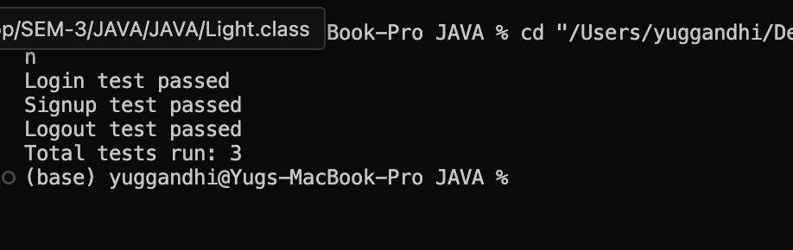

LEARNING OUTCOME:
  - Understand how custom exceptions can carry additional information such as stock shortfall.
  - Learn to manage and update inventory using arrays and methods.
  - Apply multi-catch to handle related exceptions efficiently.
  - Practice processing multiple requests independently within a loop.
  - Improve error reporting by providing meaningful exception messages.

PRAC-3
Advanced Task: Create a @Column(name) annotation and use reflection to assign values to an object’s fields by matching the column names from a header row with the corresponding values in a data row. Also, define what should happen when a required column is missing.

CODE:
import java.lang.annotation.*;
import java.lang.reflect.Field;

@Retention(RetentionPolicy.RUNTIME)
@Target(ElementType.FIELD)
@interface Column {
String name();
}

class Student {

@Column(name = "name")
String studentName;

@Column(name = "age")
String studentAge;

@Column(name = "city")
String studentCity;

public void display() {
System.out.println("Name: " + studentName);
System.out.println("Age: " + studentAge);
System.out.println("City: " + studentCity);
}
}

public class main {

public static void main(String[] args) {

String[] headerList = {"name", "age", "city"};

String[] dataList = {"Yug", "20", "Surat"};

Student studentObj = new Student();

Field[] fieldList = Student.class.getDeclaredFields();

for (Field currentField : fieldList) {

if (currentField.isAnnotationPresent(Column.class)) {

Column columnInfo = currentField.getAnnotation(Column.class);

String fieldName = columnInfo.name();

for (int index = 0; index < headerList.length; index++) {

if (headerList[index].equals(fieldName)) {

try {
currentField.setAccessible(true);
currentField.set(studentObj, dataList[index]);
} catch (Exception error) {
System.out.println("Error setting value");
}
}
}
}
}

studentObj.display();
}
}

OUTPUT SCREENSHOT:
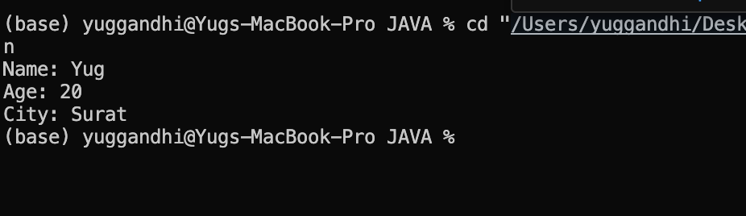

LEARNING OUTCOME:
  - Understand the purpose and working of the AutoCloseable interface.
  - Learn how try-with-resources automatically closes resources after use.
  - Observe resource closure even when an exception occurs inside the try block.
  - Understand the difference between the original and suppressed exceptions.
  - Learn how automatic resource management improves reliability and reduces manual cleanup.

